Steps :
- Place Invoice Data at server side (Server utility input folder)
- Select Download Invoice submenu from Trade ops menu in Local utility

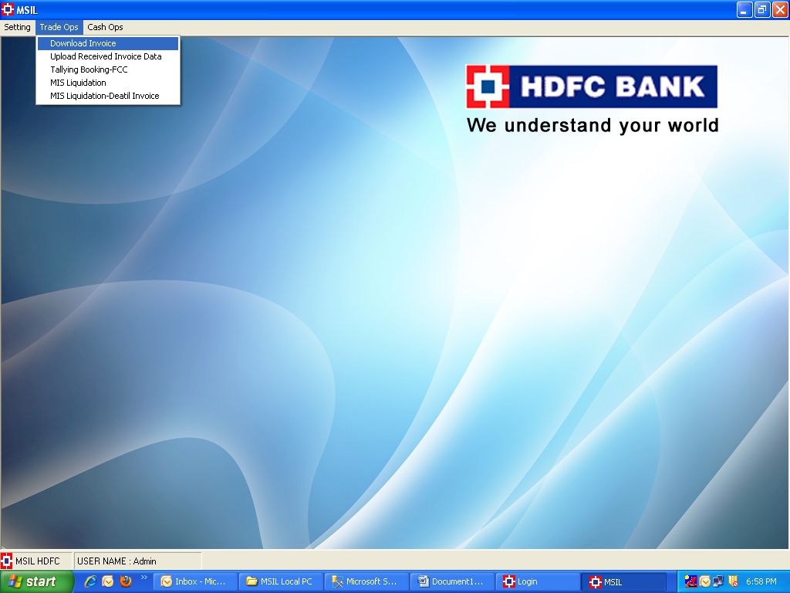

- Select invoices and click on “Selected Invoice Button”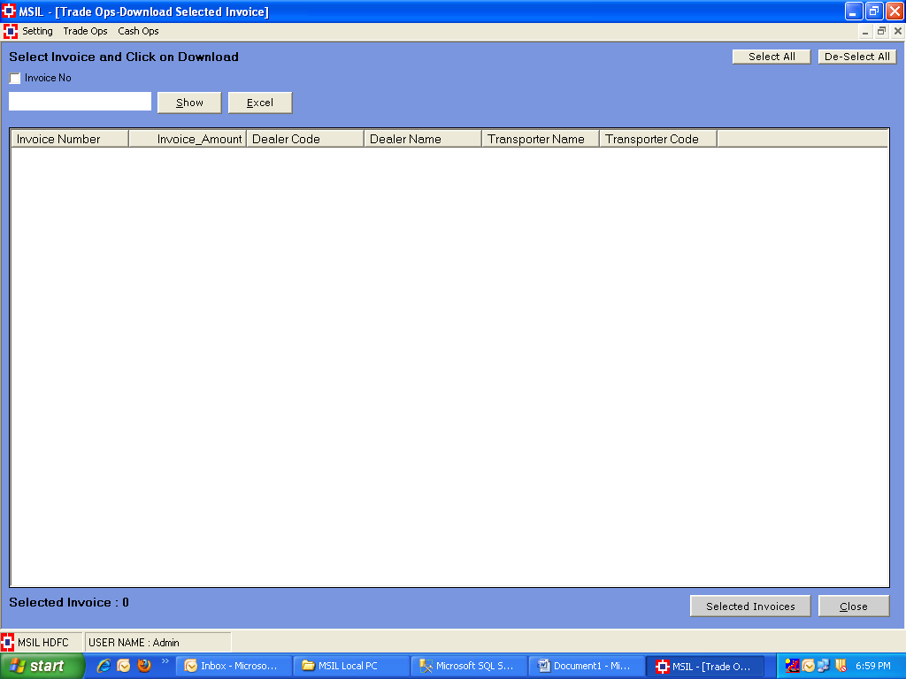
- Click On Upload invoice data

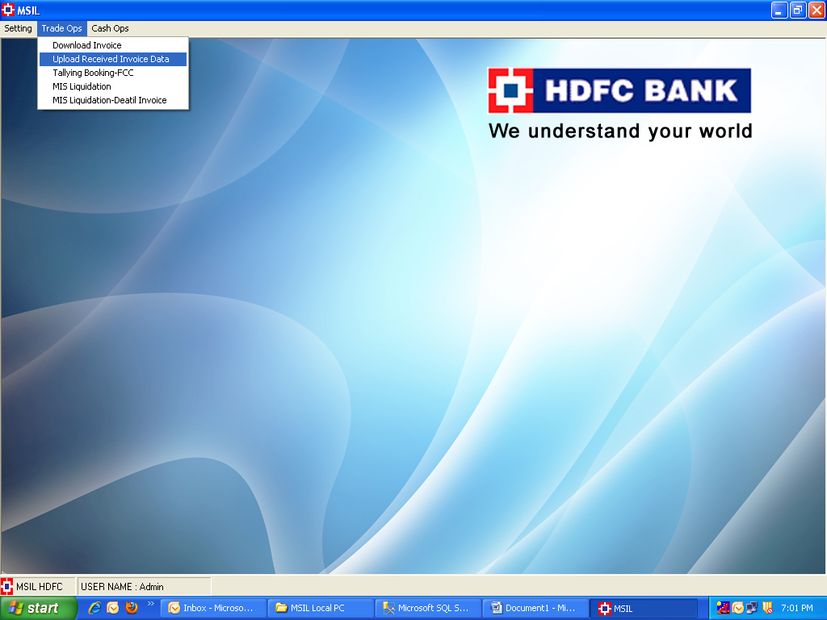

- Select Trade ops file

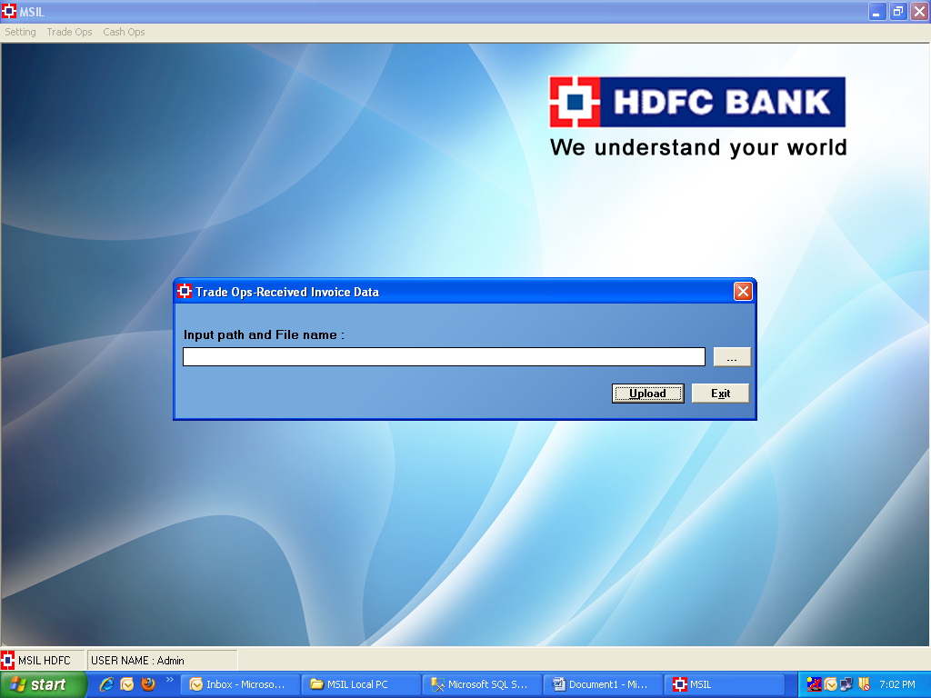

- Place order data (Server utility input folder)

- Select Payment file at Client end
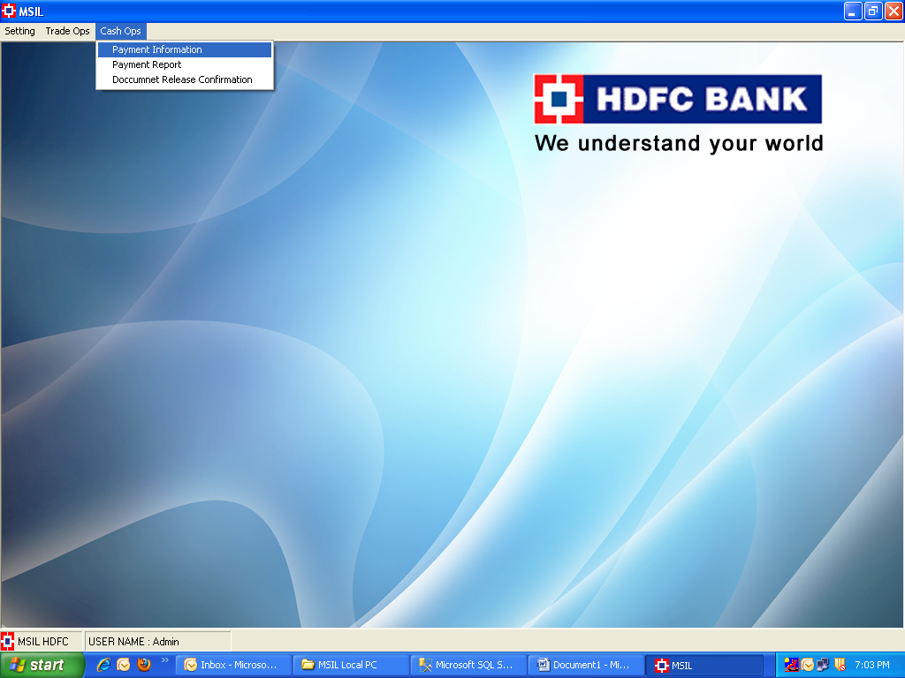

- Select Payment File
